**AIIQ3123 HUMAN COMPUTER INTERACTION (HCI)**

**Introduction**

**Human-Computer Interaction (HCI)** is an interdisciplinary field focused on the design, evaluation, and implementation of interactive computing systems for human use. It also studies the ways in which people interact with computers and the broader impact that technology has on individuals, organizations, and society.

Human-Computer Interaction (HCI) is the study and design of the interaction between humans (users) and computers (machines). It focuses on creating interfaces and systems that are intuitive, efficient, and effective for users. HCI draws from multiple disciplines such as computer science, psychology, design, and ergonomics to ensure that technology meets users' needs and enhances their experience with devices and applications.

**HCI Concepts**

1. **Interaction Design**: HCI emphasizes creating user interfaces that are intuitive, easy to use, and efficient. Interaction design deals with how users interact with the system, considering factors like layout, responsiveness, and accessibility.
2. **User-Centered Design (UCD)**: A core principle of HCI is designing systems with the user’s needs and goals at the forefront. UCD focuses on understanding the users' behavior, preferences, and challenges to create better technology solutions.
3. **Usability**: Usability is a fundamental concept in HCI, referring to how easy and effective it is for users to achieve their goals using a particular system or interface. Good usability ensures that the system is intuitive, learnable, and efficient.
4. **Affordance and Feedback**:
   * **Affordance** refers to the characteristics of an object or interface that suggest how it can be used. For example, a button affords pressing.
   * **Feedback** involves giving users clear responses to their actions. For example, clicking a button may change its color or produce a sound to indicate it has been activated.
5. **Cognitive Load**: This concept deals with how much mental effort a user needs to exert to use a system effectively. HCI aims to minimize cognitive load to improve user satisfaction and performance.
6. **Accessibility**: Ensuring that digital systems are accessible to all users, including those with disabilities, is a key concern in HCI. This may include designing for screen readers, providing captions, and ensuring that systems are usable by individuals with various impairments.

**Disciplines Involved in HCI**

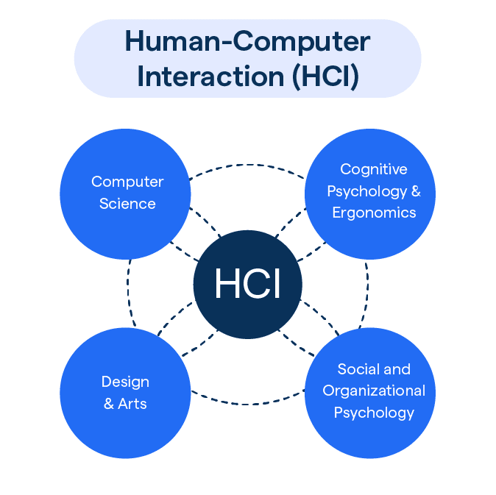

* **Computer Science**: Provides the technical foundation for creating software and hardware systems.
* **Psychology**: Helps in understanding human cognition, behavior, and how people perceive and interact with technology.
* **Design**: Ensures that interfaces and interactions are aesthetically pleasing and functional.
* **Ergonomics**: Studies the physical interaction between users and technology, ensuring that systems are comfortable and safe to use.
* **Sociology and Anthropology**: Explore the cultural and social contexts in which technology is used, influencing the design of systems that fit into people’s lives.

**Evolution of HCI**

Initially, HCI was primarily concerned with making computers usable for experts or professionals. Over time, as computers became part of daily life, the focus shifted to designing systems that are easy to use for a broader range of people, from novices to experienced users. HCI now encompasses diverse technologies, including mobile devices, virtual reality (VR), augmented reality (AR), wearable devices, and smart systems.

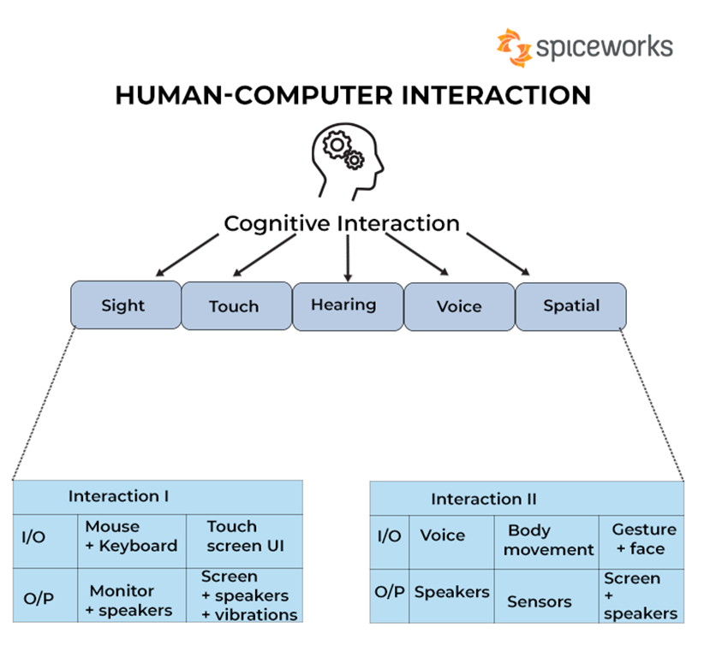

**Importance of HCI**

1. ***Enhances User Experience (UX)***

HCI aims to make technology easy to use, reducing frustration and increasing user satisfaction. By designing intuitive interfaces, HCI helps users complete tasks more efficiently and with fewer errors.

1. ***Increases Productivity***

Well-designed systems allow users to complete tasks faster and with minimal effort, leading to improved productivity. Whether it's for personal or professional use, HCI ensures that systems work smoothly and support the user's workflow.

1. ***Promotes Accessibility and Inclusivity***

HCI ensures that systems are usable by everyone, including people with disabilities. Designing accessible systems with features like screen readers, voice control, and adaptable interfaces makes technology more inclusive for diverse populations.

1. ***Supports Innovation***

HCI drives the development of new, creative forms of interaction, such as touchscreens, voice assistants, gesture-based systems, and virtual/augmented reality (VR/AR). By exploring new ways for humans to engage with computers, HCI enables the creation of cutting-edge technologies.

1. ***Reduces Cognitive Load***

By designing systems that are simple and intuitive, HCI minimizes the mental effort required to understand and use technology. This helps users to focus on their tasks rather than on figuring out how to use the system.

1. ***Improves Safety***

In fields like healthcare, aviation, and industrial applications, HCI plays a critical role in designing systems that are safe and error-proof. This reduces risks and ensures that users can operate complex systems without accidents.

1. ***Bridges the Gap Between Humans and Technology***

As technology becomes an integral part of everyday life, HCI helps bridge the gap between humans and machines, making interactions more natural, seamless, and human-centered.

In summary, HCI is crucial for making technology more user-friendly, accessible, and effective. It ensures that people can interact with computers in a way that feels natural, enhances productivity, and improves the overall user experience, while also enabling innovation in how we interact with machines.

**Challenges in HCI**

* **Adapting to Emerging Technologies**: As technology evolves (e.g., AI, AR/VR, IoT), the principles of HCI must adapt to new forms of interaction.
* **Balancing Complexity and Simplicity**: Creating powerful systems that remain easy to use is a constant challenge in HCI design.
* **Cultural Differences**: Designing systems that cater to global audiences must account for cultural preferences and differences in interaction styles.

**Future of HCI**

The future of HCI is likely to involve more natural, seamless interactions between humans and computers. Innovations such as gesture-based interfaces, voice-controlled systems, brain-computer interfaces (BCI), and smart environments will redefine how people engage with technology.

Human-Computer Interaction is an essential field that continuously evolves to enhance the way humans interact with machines, making technology more intuitive, accessible, and effective for diverse users.

**Key Components of HCI**

The key components of **Human-Computer Interaction (HCI)** focus on understanding how users interact with computers and how to design systems that enhance this interaction. These components are essential for creating user-centered, efficient, and intuitive interfaces. The main components of HCI include:

**1. The User**

* **User Characteristics**: This includes understanding the user's needs, goals, skills, experience levels, and limitations. HCI takes into account that users come from diverse backgrounds with different technical skills and cognitive abilities.
* **User Behavior**: Understanding how users interact with systems, including patterns of usage, decision-making processes, and behavior under different conditions, helps in designing more user-friendly systems.
* **User Experience (UX)**: The overall feeling users have when interacting with a system. A positive UX means the system is easy to use, intuitive, and meets the user’s needs.

**2. The Interface**

* **Input and Output Devices**: This includes hardware components like keyboards, mice, touchscreens, voice input, VR controllers, and displays. These devices serve as the primary means for users to interact with the computer.
* **User Interface (UI)**: The design of graphical elements such as buttons, icons, menus, and windows. UI design focuses on how information is presented to the user and how they navigate through the system.
* **Interaction Modes**: Different ways users can interact with the system, such as through touch, voice, gestures, or typing. HCI studies how to make these modes as natural and efficient as possible.

**3. The Task**

* **Task Analysis**: Understanding the specific tasks that users want to accomplish when interacting with the system. This helps designers structure the interface and interaction to streamline these tasks.
* **Task Support**: Ensuring that the system adequately supports the user’s goals by providing appropriate tools, feedback, and guidance throughout the interaction.

**4. Usability**

* **Learnability**: How easily new users can start using the system. HCI aims to make systems intuitive so users can quickly learn how to use them without extensive training.
* **Efficiency**: How fast and effectively users can perform tasks once they are familiar with the system. A highly efficient system allows users to accomplish their goals with minimal effort.
* **Memorability**: After users leave the system and come back later, they should be able to remember how to use it without needing to relearn everything.
* **Error Prevention and Recovery**: Minimizing the chances of user errors and ensuring that, when errors do occur, users can recover easily. This involves providing clear instructions, feedback, and error messages.
* **Satisfaction**: How pleasant or satisfying the overall experience is for the user. A system that feels rewarding to use can lead to higher user engagement and satisfaction.

**5. Context of Use**

* **Environmental Factors**: Where and how the system is used matters. For example, designing a mobile app for outdoor use would require different considerations than an application used in a quiet office.
* **Social Context**: Involves understanding how users interact with the system within social environments. Collaborative tools may need features that support multiple users working together, or systems may need to account for group behavior.
* **Cultural Context**: Cultural differences affect how users interact with systems. Different cultures may have varying preferences for colors, symbols, or interface layouts.

**6. Feedback**

* **System Response**: Feedback is crucial in letting users know that their input has been received and understood. This includes visual, auditory, or tactile cues that guide the user through tasks and processes.
* **Timeliness of Feedback**: Users need immediate or appropriately timed responses to their actions, such as showing a progress bar during a file upload or playing a sound when a button is pressed.

**7. Ergonomics**

* **Physical Interaction**: This involves the study of how users physically interact with devices, ensuring that the hardware design (e.g., keyboards, touchscreens) promotes comfort and prevents strain or injury.
* **Human Factors**: Incorporating principles from ergonomics to design systems that account for the physical and mental capabilities of users. This includes factors like visual strain, typing speed, and posture during use.

**8. Cognitive Aspects**

* **Cognitive Load**: Refers to the mental effort required to use a system. HCI aims to reduce cognitive load by simplifying interfaces and making interactions more intuitive.
* **Mental Models**: Users develop mental models, or expectations, about how systems should work. HCI strives to align system design with these models so that users can predict and understand system behavior easily.
* **Attention and Perception**: Designing systems that match the user’s perceptual abilities (e.g., using colors or contrast to highlight important elements) and capturing the user’s attention at the right times.

**9. Accessibility**

* **Designing for All Users**: Ensuring that the system can be used by people with varying abilities, including those with disabilities such as vision, hearing, or mobility impairments. This may involve providing alternative input methods, screen readers, or customizable interfaces.
* **Inclusive Design**: HCI focuses on making systems inclusive, so no one is excluded due to their physical or cognitive abilities.

**10. Interaction Techniques**

* **Direct Manipulation**: Interaction techniques like drag-and-drop, resizing, and touch gestures that allow users to directly interact with objects on the screen.
* **Command-Based Interfaces**: Users interact with the system by typing commands (e.g., command-line interfaces).
* **Natural User Interfaces (NUI)**: Interfaces that allow for natural interactions, such as gesture-based or voice-controlled systems, that mimic real-world actions.

**11. Evaluation and Testing**

* **Usability Testing**: Involves testing the system with real users to identify usability issues and areas for improvement. User feedback is essential for refining the design.
* **Prototyping**: Creating early models of the system (low-fidelity or high-fidelity prototypes) to test and refine interactions before full implementation.
* **Iterative Design**: HCI follows a process of continuous improvement, where designs are tested, evaluated, and revised to better meet user needs.

**12. Ethics in HCI**

* **Privacy and Security**: Ensuring that systems protect users' data and personal information.
* **Ethical Considerations**: HCI considers the ethical implications of system design, including how technology may impact society, user autonomy, and well-being.

These components work together to create systems that are not only functional but also easy, efficient, and satisfying for users to interact with.